Wireshark Lab:
Ethernet and ARP v8.0

Supplement to Computer Networking: A Top-Down Approach, 8th ed., J.F. Kurose and K.W. Ross

“Tell me and I forget. Show me and I remember. Involve me and I understand.” Chinese proverb

© 2005-2020, J.F Kurose and K.W. Ross, All Rights Reserved

In this lab, we’ll investigate the Ethernet protocol and the ARP protocol. Before beginning this lab, you’ll probably want to review sections 6.4.1 (Link-layer addressing and ARP) and 6.4.2 (Ethernet) in the text. RFC 826 (ftp://ftp.rfc-editor.org/in-notes/std/std37.txt) contains the gory details of the ARP protocol, which is used by an IP device to determine the IP address of a remote interface whose Ethernet address is known.

1. Capturing and analyzing Ethernet frames

Let’s begin by capturing a set of Ethernet frames to study. Do the following:

- First, make sure your browser’s cache is empty. To do this under Mozilla Firefox V3, select Tools->Clear Recent History and check the box for Cache. For Internet Explorer, select Tools->Internet Options->Delete Files. Start up the Wireshark packet sniffer
- Enter the following URL into your browser
http://gaia.cs.umass.edu/wireshark-labs/HTTP-ethereal-lab-file3.html
Your browser should display the rather lengthy US Bill of Rights.
- Stop Wireshark packet capture. First, find the packet numbers (the leftmost column in the upper Wireshark window) of the HTTP GET message that was sent from your computer to gaia.cs.umass.edu, as well as the beginning of the HTTP response message sent to your computer by gaia.cs.umass.edu. You should see a screen that looks something like this (where packet 4 in the screen shot below contains the HTTP GET message). Note that you have to generate the packet trace by yourself, i.e., you cannot use the packet trace from the textbook resource.

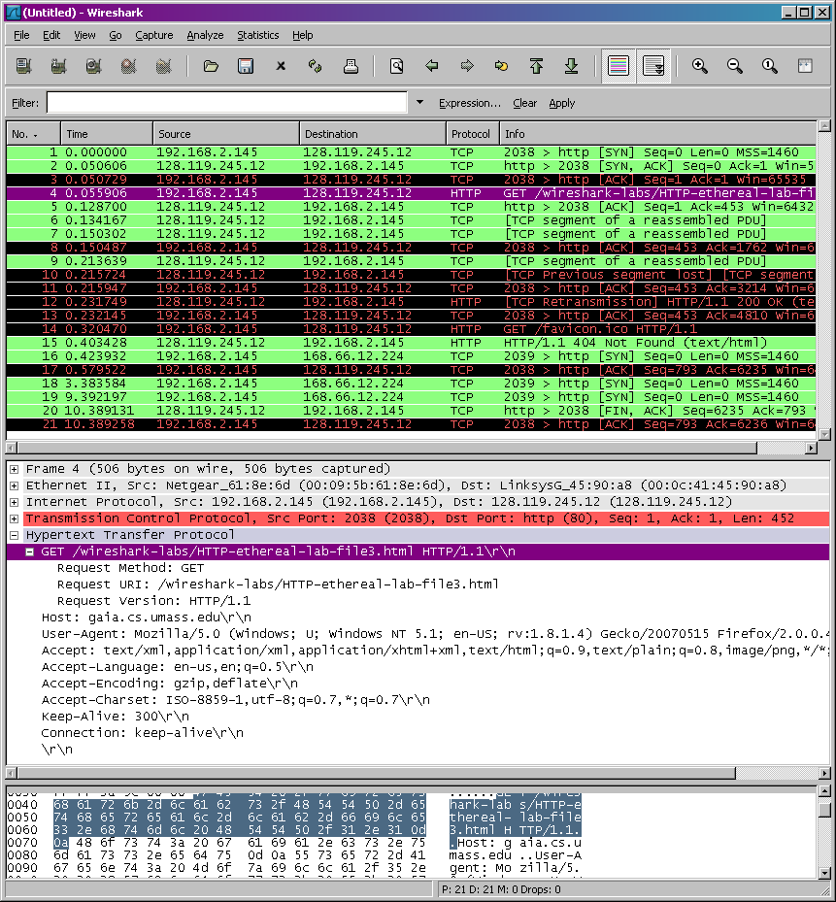

- Since this lab is about Ethernet and ARP, we’re not interested in IP or higher-layer protocols. So let’s change Wireshark’s “listing of captured packets” window so that it shows information only about protocols below IP. To have Wireshark do this, select Analyze->Enabled Protocols. Then uncheck the IP box and select OK. You should now see a Wireshark window that looks like:

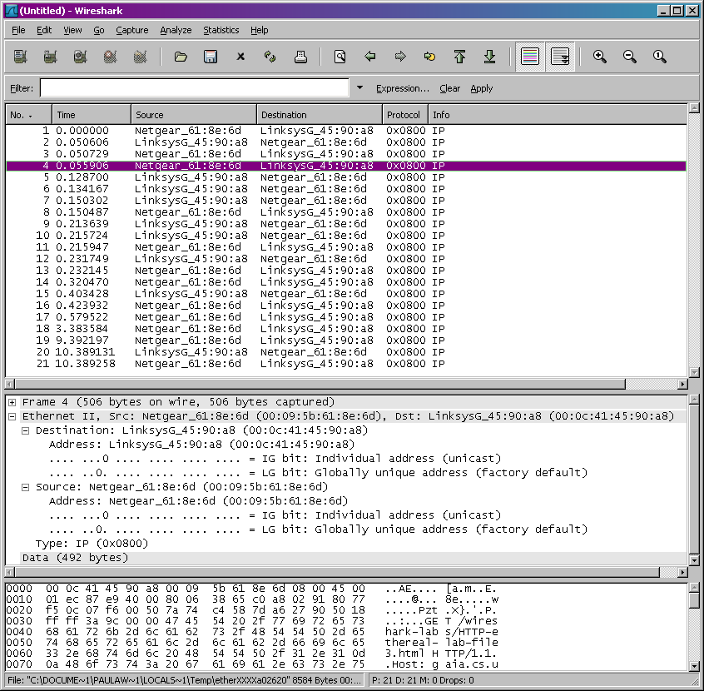

In order to answer the following questions, you’ll need to look into the packet details and packet contents windows (the middle and lower display windows in Wireshark).

Select the Ethernet frame containing the HTTP GET message. (Recall that the HTTP GET message is carried inside of a TCP segment, which is carried inside of an IP datagram, which is carried inside of an Ethernet frame; reread section 1.5.2 in the text if you find this encapsulation a bit confusing). Expand the Ethernet II information in the packet details window. Note that the contents of the Ethernet frame (header as well as payload) are displayed in the packet contents window.

Answer the following questions, based on the contents of the Ethernet frame containing the HTTP GET message. Whenever possible, when answering a question you should hand in a printout of the packet(s) within the trace that you used to answer the question asked. Annotate the printout to explain your answer. To print a packet, use File->Print, choose Selected packet only, choose Packet summary line, and select the minimum amount of packet detail that you need to answer the question.
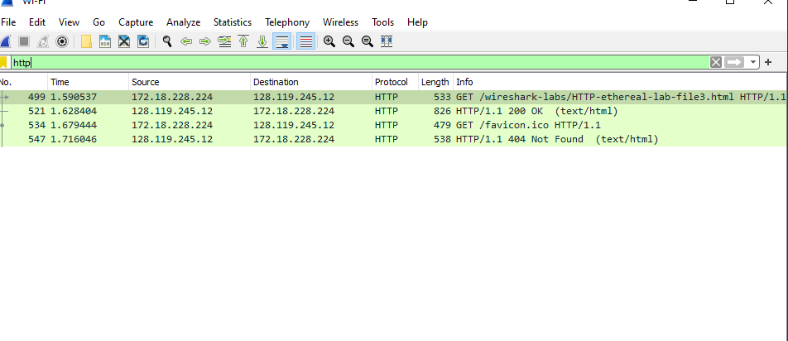
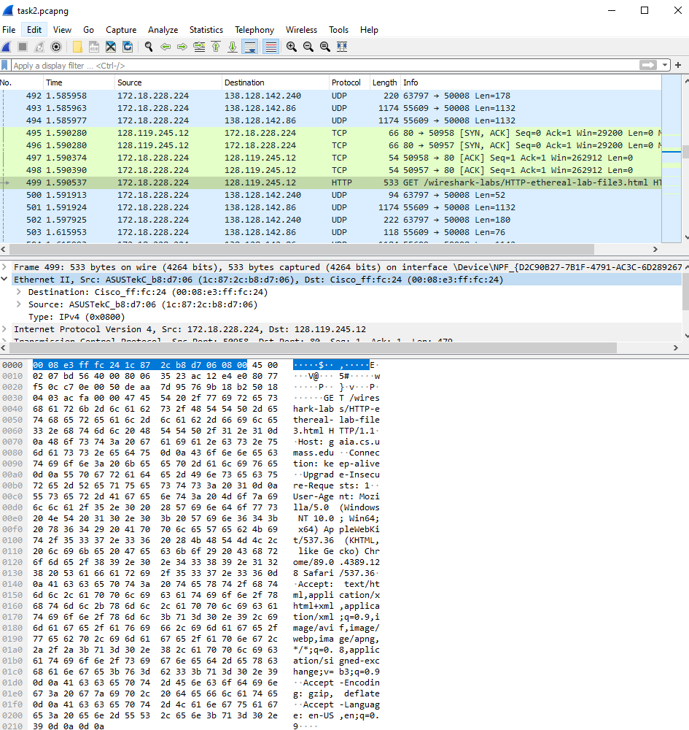

- What is the 48-bit Ethernet address of your computer?
1c:87:2c:b8:d7:06
- What is the 48-bit destination address in the Ethernet frame? Is this the Ethernet address of gaia.cs.umass.edu? (Hint: the answer is no). What device has this as its Ethernet address? [Note: this is an important question, and one that students sometimes get wrong. Re-read pages 468-469 in the text and make sure you understand the answer here.]
00:08:e3:ff:fc:24 ; This is not the Ethernet address of gaia.cs.umass.edu. It is the mac address for my router or internet gateway address.

- Give the hexadecimal value for the two-byte Frame type field. What upper layer protocol does this correspond to?
0x0800 ; IP
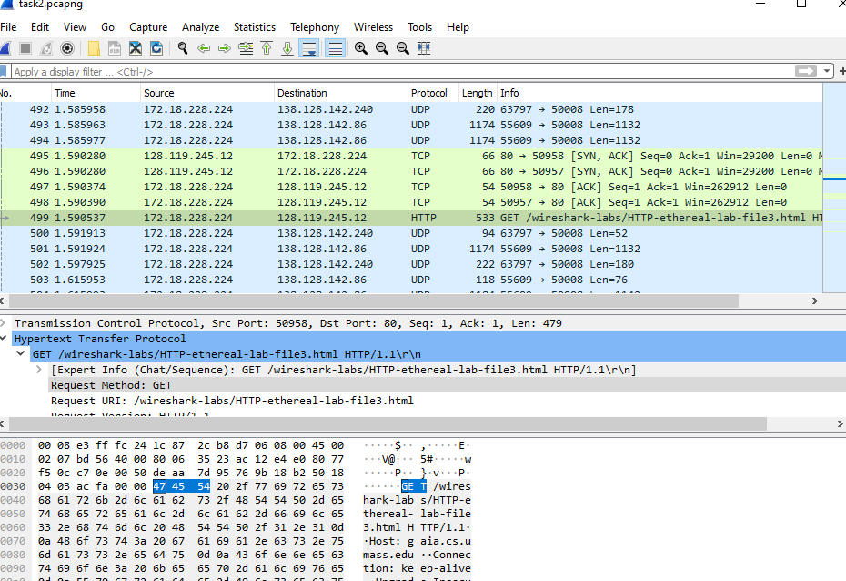
- How many bytes from the very start of the Ethernet frame does the ASCII “G” in “GET” appear in the Ethernet frame?
54 bytes away, counting from 00 from the top left.

Next, answer the following questions, based on the contents of the Ethernet frame containing the first byte of the HTTP response message.
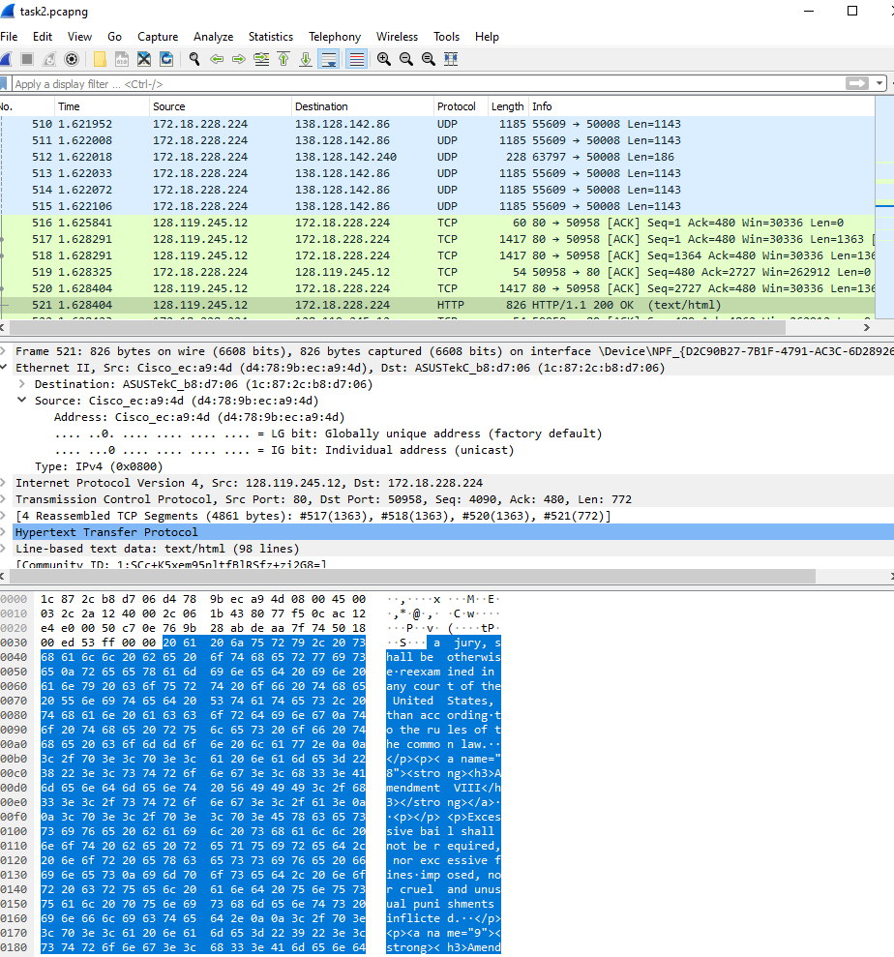
- What is the value of the Ethernet source address? Is this the address of your computer, or of gaia.cs.umass.edu (Hint: the answer is no). What device has this as its Ethernet address?
D4:78:9b:ec:a9:4d ; It is the address of the local router/ internet gateway address
- What is the destination address in the Ethernet frame? Is this the Ethernet address of your computer?
1c:87:2c:b8:d7:06 ; yes it is.
- Give the hexadecimal value for the two-byte Frame type field. What upper layer protocol does this correspond to?
0x0800 ; IP protocol.
- How many bytes from the very start of the Ethernet frame does the ASCII “O” in “OK” (i.e., the HTTP response code) appear in the Ethernet frame?
13 bytes away.
2. The Address Resolution Protocol

In this section, we’ll observe the ARP protocol in action. We strongly recommend that you re-read section 6.4.1 in the text before proceeding.

ARP Caching

Recall that the ARP protocol typically maintains a cache of IP-to-Ethernet address translation pairs on your comnputer The arp command (in both MSDOS and Linux/Unix) is used to view and manipulate the contents of this cache. Since the arp command and the ARP protocol have the same name, it’s understandably easy to confuse them. But keep in mind that they are different - the arp command is used to view and manipulate the ARP cache contents, while the ARP protocol defines the format and meaning of the messages sent and received, and defines the actions taken on message transmission and receipt.

Let’s take a look at the contents of the ARP cache on your computer:

- MS-DOS. The arp command is in c:\windows\system32, so type either “arp” or “c:\windows\system32\arp” in the MS-DOS command line (without quotation marks).
- Linux/Unix/MacOS. The executable for the arp command can be in various places. Popular locations are /sbin/arp (for linux) and /usr/etc/arp (for some Unix variants).

The Windows arp command with no arguments will display the contents of the ARP cache on your computer. Run the arp command.
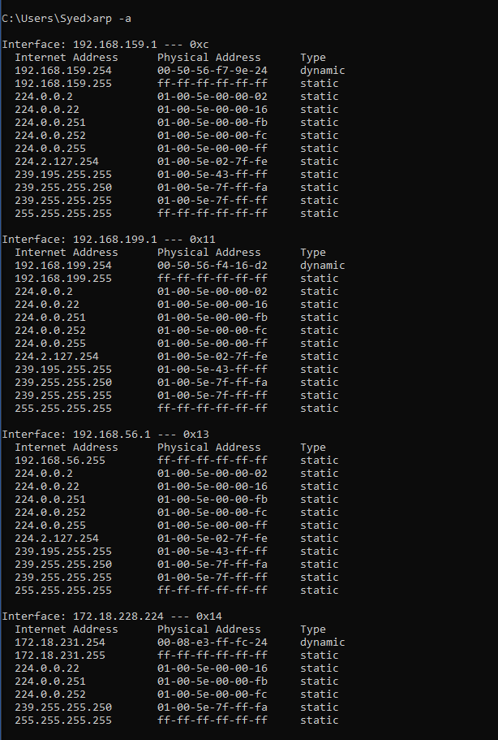
- Write down the contents of your computer’s ARP cache. What is the meaning of each column value?
The Internet Address column contains the IP address, the Physical Address column contains the MAC address, and the type indicates the protocol type.

In order to observe your computer sending and receiving ARP messages, we’ll need to clear the ARP cache, since otherwise your computer is likely to find a needed IP-Ethernet address translation pair in its cache and consequently not need to send out an ARP message.

- MS-DOS. The MS-DOS arp –d * command will clear your ARP cache. The –d flag indicates a deletion operation, and the * is the wildcard that says to delete all table entries.
- Linux/Unix/MacOS. The arp –d * will clear your ARP cache. In order to run this command you’ll need root privileges. If you don’t have root privileges and can’t run Wireshark on a Windows machine, you can skip the trace collection part of this lab and just use the trace discussed in the earlier footnote.

Observing ARP in action

Do the following:

- Clear your ARP cache, as described above.
- Next, make sure your browser’s cache is empty. To do this under Mozilla Firefox V3, select Tools->Clear Recent History and check the box for Cache. For Internet Explorer, select Tools->Internet Options->Delete Files.
- Start up the Wireshark packet sniffer
- Enter the following URL into your browser
http://gaia.cs.umass.edu/wireshark-labs/HTTP-wireshark-lab-file3.html
Your browser should again display the rather lengthy US Bill of Rights.
- Stop Wireshark packet capture. Again, we’re not interested in IP or higher-layer protocols, so change Wireshark’s “listing of captured packets” window so that it shows information only about protocols below IP. To have Wireshark do this, select Analyze->Enabled Protocols. Then uncheck the IP box and select OK. You should now see an Wireshark window that looks like (but different):

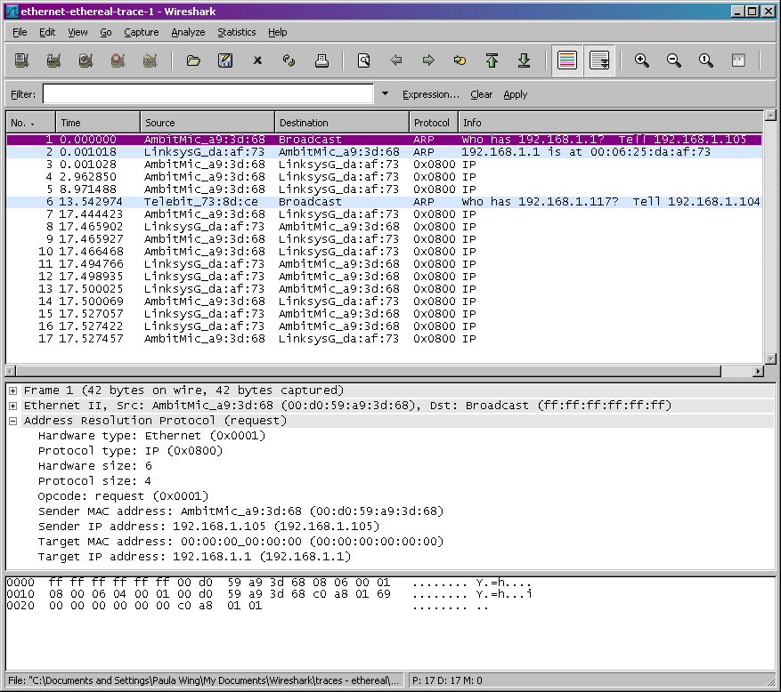

In the example above, the first two frames in the trace contain ARP messages (as does the 6th message). The screen shot above corresponds to the trace referenced in footnote 1.
Answer the following questions:
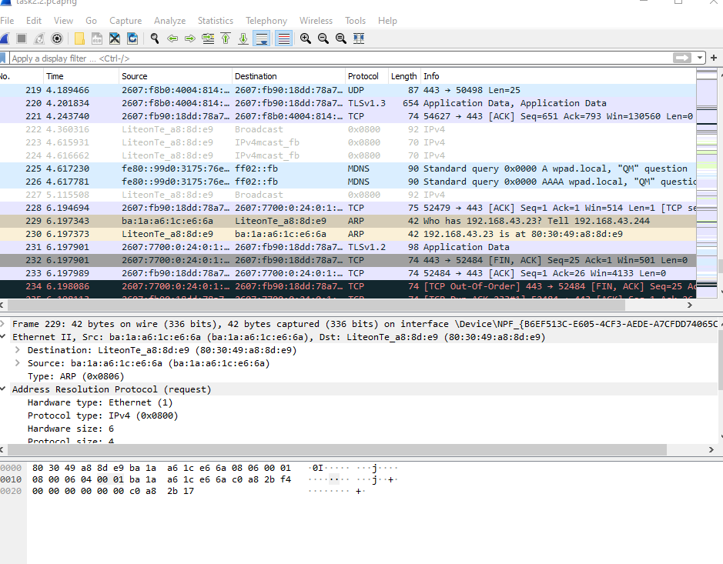
arp -a
arp -d *
netsh interface ip delete arpcache
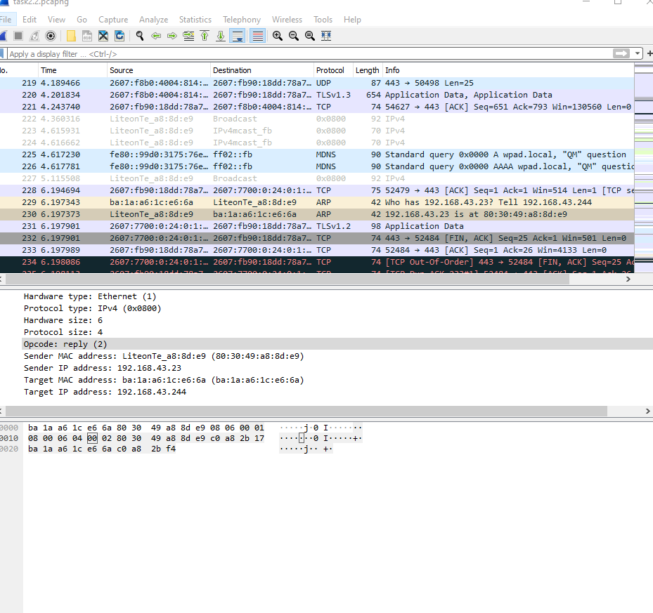
- What are the hexadecimal values for the source and destination addresses in the Ethernet frame containing the ARP request message?
Source – ba:1a:a6:1c:e6:6a
Destination – 80:30:49:a8:8d:e9
- Give the hexadecimal value for the two-byte Ethernet Frame type field. What upper layer protocol does this correspond to?
0x0806, ARP.
- Download the ARP specification from
ftp://ftp.rfc-editor.org/in-notes/std/std37.txt. A readable, detailed discussion of ARP is also at http://www.erg.abdn.ac.uk/users/gorry/course/inet-pages/arp.html.
https://erg.abdn.ac.uk/users/gorry/course/inet-pages/arp.html
  - How many bytes from the very beginning of the Ethernet frame does the ARP opcode field begin? 20
  - What is the value of the opcode field within the ARP-payload part of the Ethernet frame in which an ARP request is made? 1
  - Does the ARP message contain the IP address of the sender?
Yes, here 192.168.43.244
  - Where in the ARP request does the “question” appear – the Ethernet address of the machine whose corresponding IP address is being queried?
In the Target MAC address field in the form of 00:00:00:00:00:00. Once the MAC address is resolved, this would be populated with the corresponding complete MAC address of the server or its relevant router.
- Now find the ARP reply that was sent in response to the ARP request.
  - How many bytes from the very beginning of the Ethernet frame does the ARP opcode field begin? 20
  - What is the value of the opcode field within the ARP-payload part of the Ethernet frame in which an ARP response is made? 2
  - Where in the ARP message does the “answer” to the earlier ARP request appear – the IP address of the machine having the Ethernet address whose corresponding IP address is being queried?
The previously blank Target MAC Address field is now the Sender’s MAC Address. It is the servers MAC address 80:30:49:a8:8d:e9
- What are the hexadecimal values for the source and destination addresses in the Ethernet frame containing the ARP reply message?
Source – 80:30:49:a8:8d:e9
Destination – ba:1a:a6:1c:e6:6a
Extra Tasks (You can ignore)
EX-1. The arp command:
arp -s InetAddr EtherAddr
allows you to manually add an entry to the ARP cache that resolves the IP address InetAddr to the physical address EtherAddr. What would happen if, when you manually added an entry, you entered the correct IP address, but the wrong Ethernet address for that remote interface?
EX-2. What is the default amount of time that an entry remains in your ARP cache before being removed. You can determine this empirically (by monitoring the cache contents) or by looking this up in your operation system documentation. Indicate how/where you determined this value.

References to figures and sections are for the 8th edition of our text, Computer Networks, A Top-down Approach, 8th ed., J.F. Kurose and K.W. Ross, Addison-Wesley/Pearson, 2020.
What do we mean by “annotate”? If you hand in a paper copy, please highlight where in the printout you’ve found the answer and add some text (preferably with a colored pen) noting what you found in what you ‘ve highlight. If you hand in an electronic copy, it would be great if you could also highlight and annotate.

